Rapid Pilot Program 2024

Contents

What you will learn 1

Prerequisites 1

Simulator Setup 2

Simulator Test. 5

Takeaway 13

# What you will learn: Simulator

Day 1 of 5. Topics covered :

SAP business objects simulator

* Publish SAP simulated events that represents mocked JSON structures
* Publish events from 5 different SAP object- Salesorders, Business Partners, Chart of Accounts, Material Master, and Notifications
* Test Simulated SAP events being published and subscribed too using the AEM broker and the SAP Ui5 dashboard.

# Prerequisites

### 1: BTP subaccount with a developer space enabled in Cloud Foundry 2: CloudFoundry CLI installation (Only needed if upload doesn't work)

To start with, we will be installing the CloudFoundry CLI for the deployment process. Follow the steps mentioned over here Installing the CF CLI for detailed instructions on this.

### 3 : Downloading the deployable artifacts

Download the following files artefact files and save them in the same directory:

* capm-erp-simulation-exec.jar : https://github.com/Solacelabs/aem-sap­ integration/blob/main/deployable/capm-erp-simulation-exec.jar
* manifest.yml: https://github.com/Solacelabs/aem-sap­ integration/blob/main/deployable/manifest.yml

## SAP Simulator setup

The SAP Cloud Application Programming Model (CAP) is a framework of languages, libraries, and tools for building enterprise-grade services and applications. It guides developers along a 'golden path' of proven best practices and a great wealth of out-of-the-box solutions to recurring tasks. CAP­ based projects benefit from a primary focus on domain. Instead of delving into overly technical disciplines, we focus on accelerated development and safeguarding investments in a world of rapidly changing cloud technologies.

For more information on SAP CAP, you can refer to the link: SAP Cloud Application Programming Model

To showcase the integration capability of SAP CAP and AEM, we have created a CAP based Java microservice which will publish different SAP business object events into your AEM instance. This application can be deployed in your SAP CloudFoundry space.

#### 1 : Identify CF Domain address

In order to deploy the simulator to your CloudFoundry space, you need to identify the domain address which is a part of the API endpoint.

* Navigate to your SAP BTP Sub account Overview page
* Copy the specified section of the API Endpoint in the Cloud Foundry Environment as shown below:

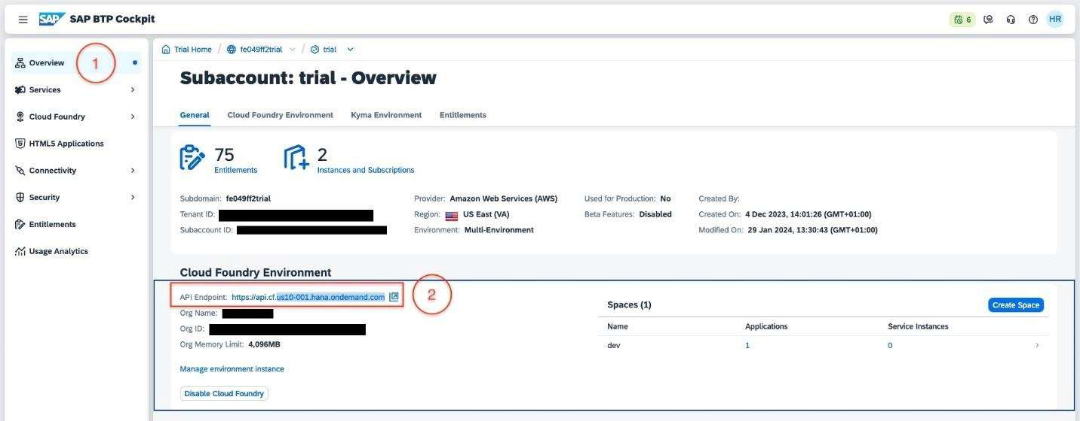

##### 2: Update the manifest file

* Open the manifest.yml file which you downloaded earlier in a text editor
* Replace the placeholder text {API_ENDPOINT} on line number 12 with the value copied from the API Endpoint
* Also in the route name "capm-erp-simulation-aem-workshop.cfapps.{API_ENDPOINT}, change the name workshop to your company name
* Example capm-erp-simulation-aem-solace.cfapps.{API_ENDPOINT},

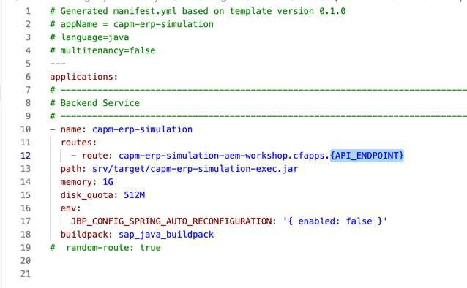

* After replacing your manifest file should look like this:

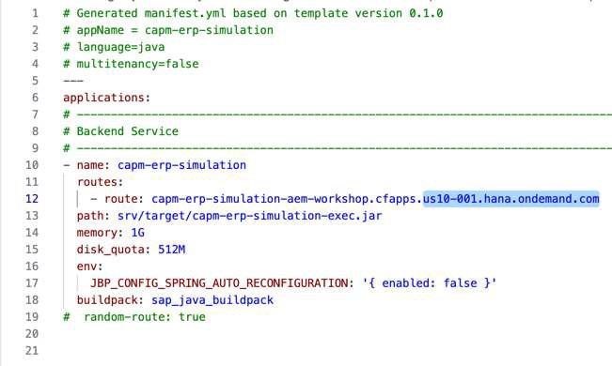

Save and close the file.

##### 3 : Deploying the SAP Simulator application

* Navigate to the CloudFoundry space where you want to deploy the application and click on the **Deploy Application** button as below :

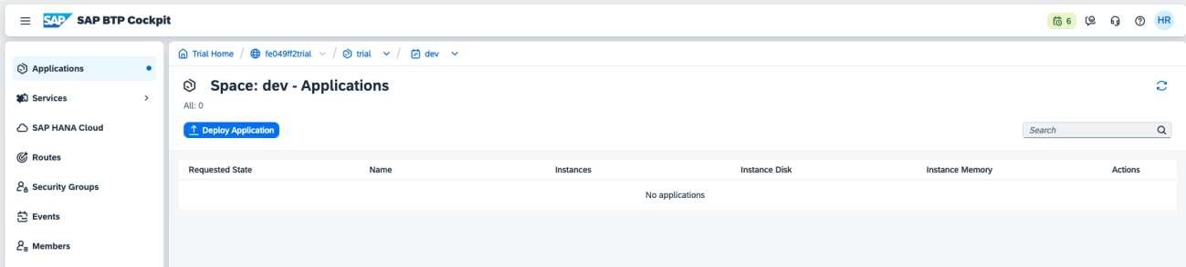

* A **Deploy Application** modal window will be displayed where you can browse and select the **capm-erp-simulation-exec.jar** and **manifest.yml** as below

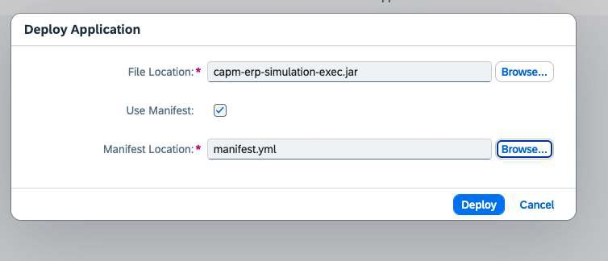

* Click on the deploy button **Note : this action will take some time to completely execute as it uploads the jar deployable and also start the application.**
* Once the upload is completely executed, you should be able to see the application deployed and running as below:

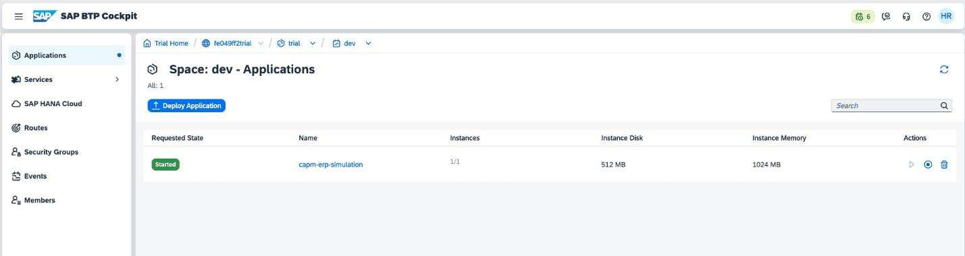

### *CMD Line Deployment Option* Login to CloudFoundry space

You can log in to the SAP CloudFoundry space in your account as below:

Use the command : cf login to log in, which will prompt for your SAP login credentials. Once authenticated, the details of the default cloudfoundry space will be displayed.

### Deploying the SAP Simulator application

Navigate to the directory where the above deployable artifact files are saved.

Run the command cf push --random-route which will upload the jar file and use the manifest.yml for properties. Note : this command will take some time to completely execute as it uploads the jar deployable and also start the application.

Once the command is completely executed, run the command cf apps to view a listing of the apps in your cloudfoundry space

Verify that the app capm-erp-simulation is deployed and started

Testing the Simulator

##### 1 : Accessing the SAP Simulator application

* Navigate to the Cloud Foundry environment in your SAP BTP Cockpit
* You should see a screen like below

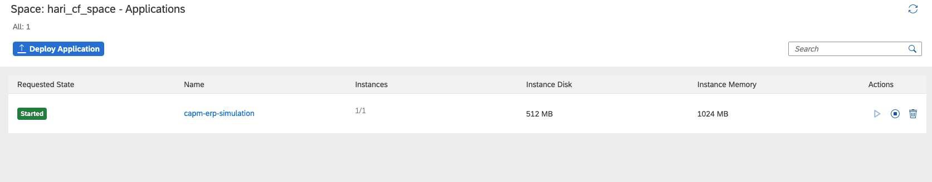

* Click on the application name: **capm-erp-simulation** and enter the application overview screen.

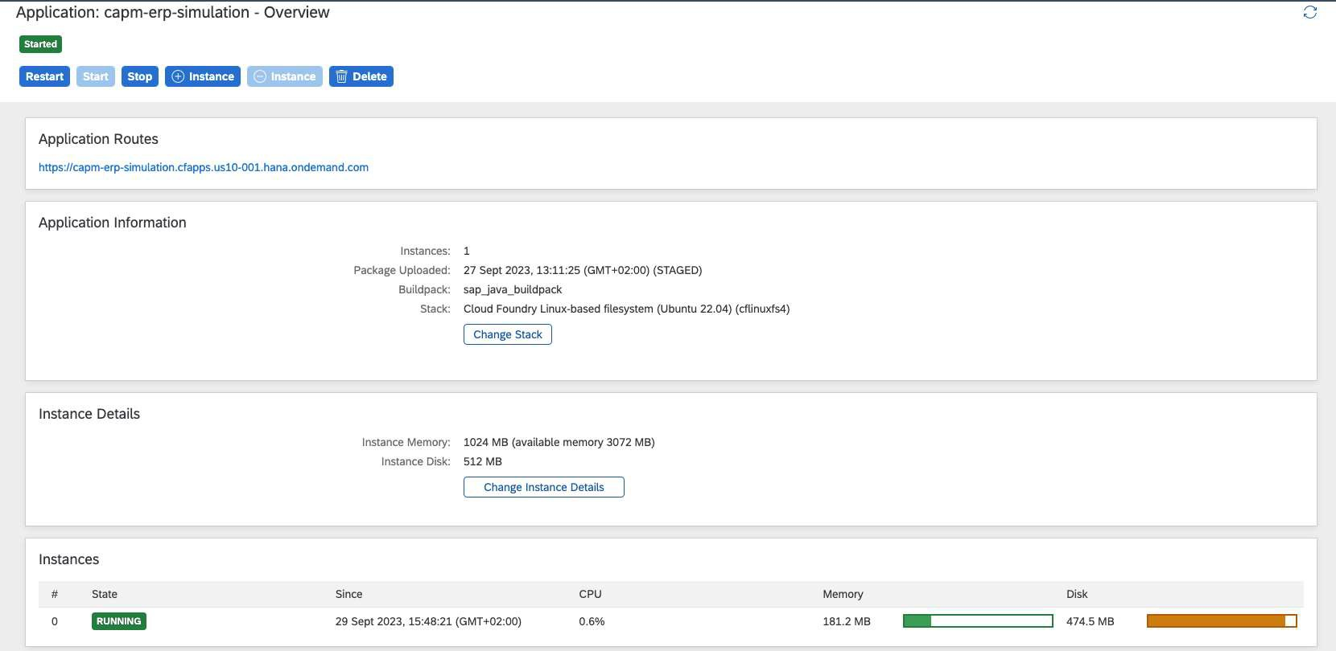

* Click on the application route as highlighted below. Note: this route url will differ from for different SAP BTP accounts.

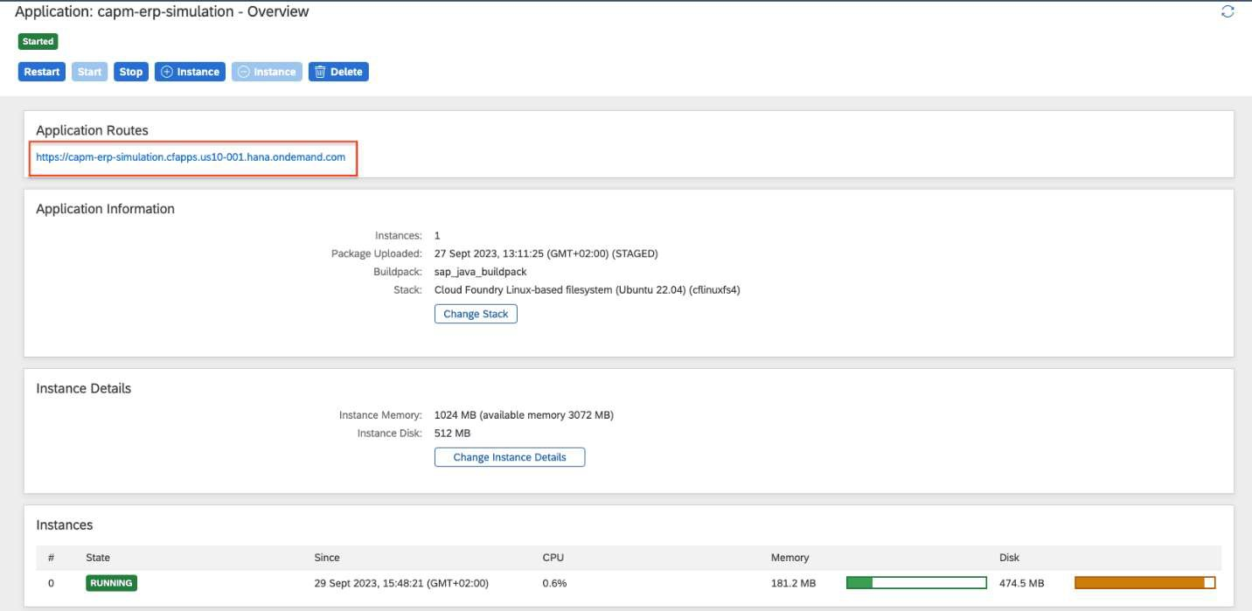

### 2 : Connecting to SAP AEM and running the simulator

* As you click on the above application route **url,** you will be redirected to the simulator screen as

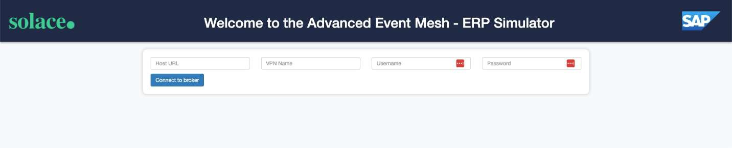below

Here you can connect to your SAP AEM instance to publish events.

As long as both of your SAP AEM services are connected to the event mesh, messages will flow freely between the two of them. Due to this intelligent routing, you can connect the simulator to either of your AEM services created earlier.

* The connection parameters for the simulator can be captured from below:

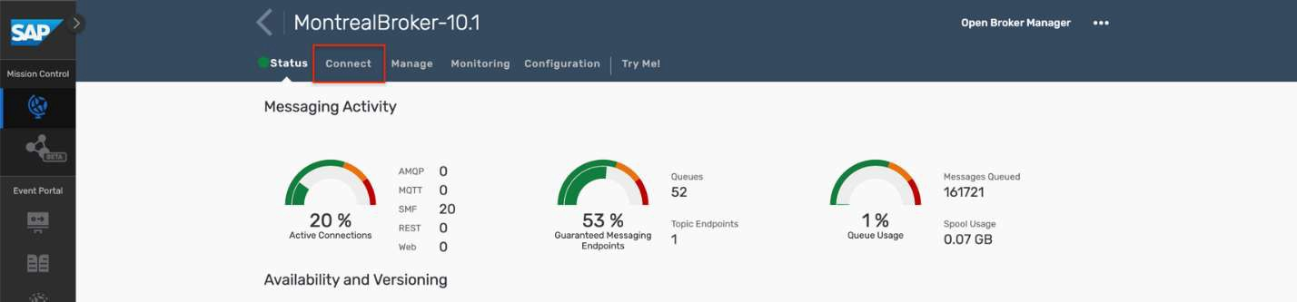

Ein Bild, das Screenshot, Text, Software enthält.

Enter the appropriate value as specified below

* Host URL: Public Endpoint
* VPN Name : Message VPN
* Username: Username
* Password : Password

You can choose which events to simulate and its frequency by using the sliders. As you change a schedule, the submit button in the bottom will be enabled.

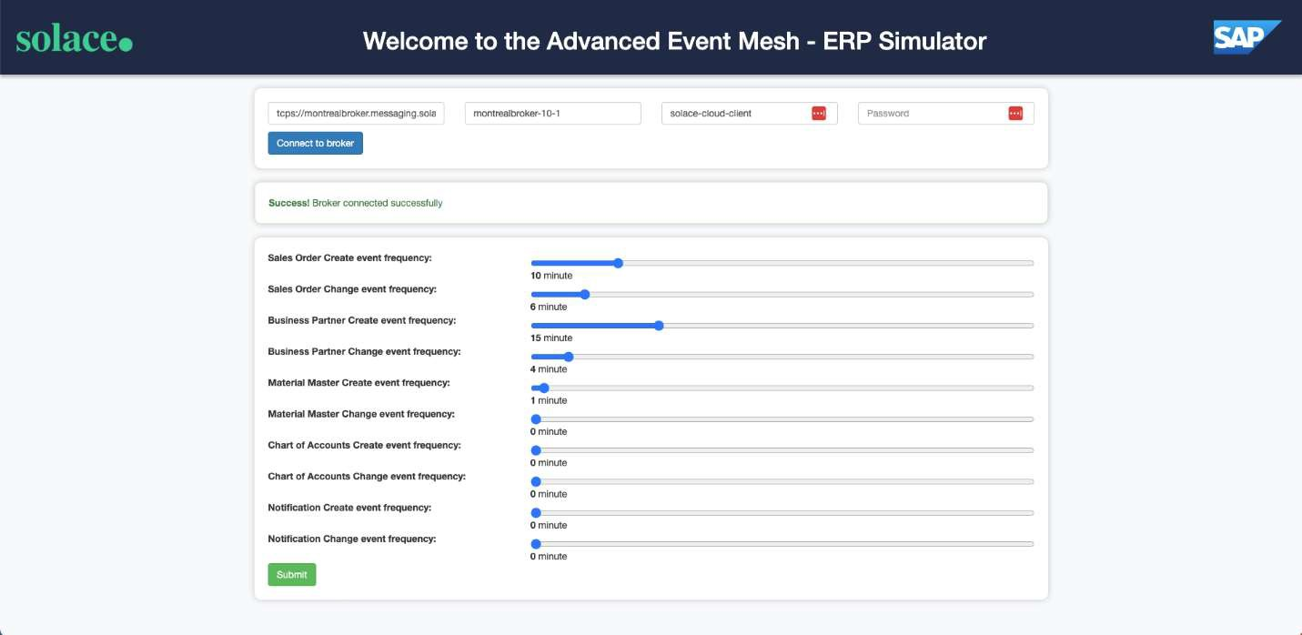

* In case you want to disable any of the events, then pull the slider to **O** and click submit and the event will be disabled immediately.

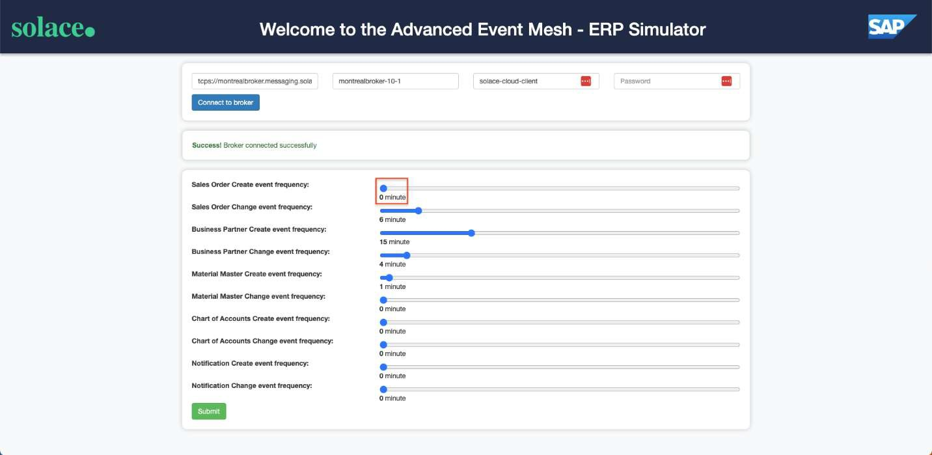

#### 3 : Test the incoming events

You can easily test the simulator by using the **Cluster Manager - Try-Me** as below:> aside negative

* As mentioned earlier due to the intelligent routing in the event mesh, you can connect the

simulator and try-me to either of the two SAP AEM services in the event mesh and see the messages flowing freely.

Ein Bild, das Text, Screenshot, Design enthält.

Click on the **Connect Open Broker Manger** button in the **Subscriber** side of the panel as below

Ein Bild, das Screenshot, Software, Text enthält.

Maintain Connection details from Web_Messaging and connect Published and Subscriber.

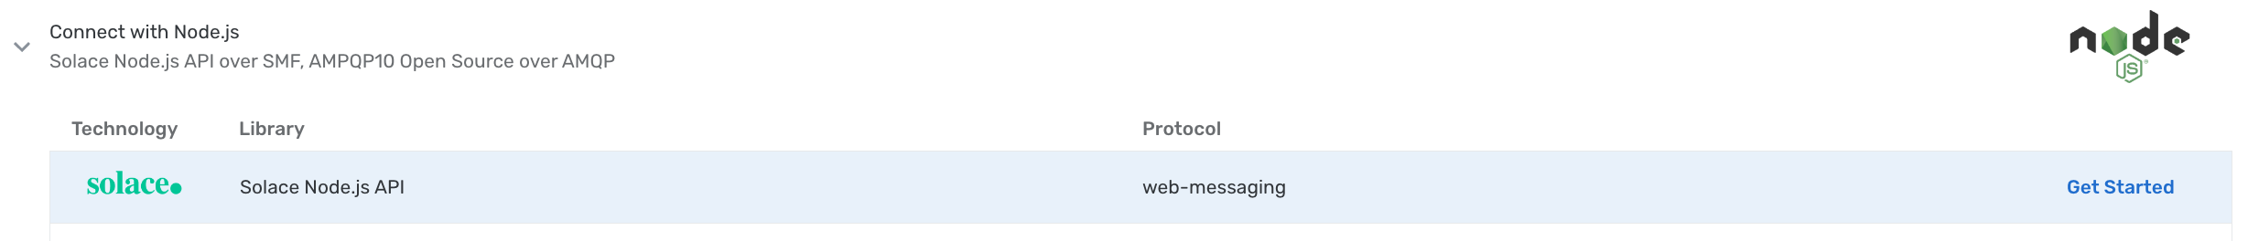

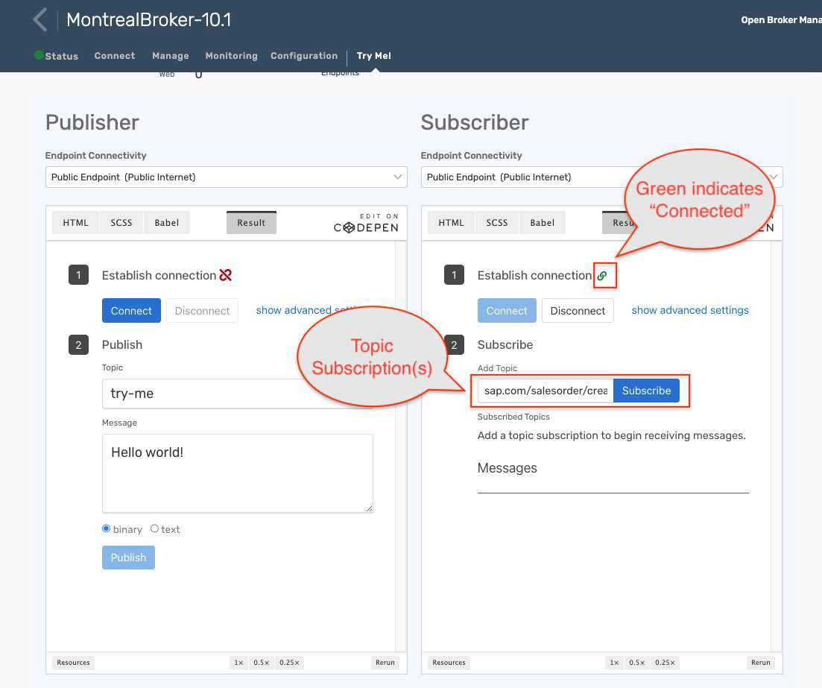

* + You can use the below topic structures for different event types:
* **Sales Order** :
  + Create:sap.com/salesorder/create/>
  + Change:sap.com/salesorder/change/>
* **Business Partner** :
  + Create:sap.com/businesspartner/create/>
  + Change:sap.com/businesspartner/change/>
* **Chart of Accounts** :
  + Create:sap.com/chartofaccounts/create/>
  + Change:sap.com/chartofaccounts/change/>
* **Material Master** :
  + Create: sap.com/material/create/>
  + Change:sap.com/material/change/>
* **Notifications** :
  + Create:sap.com/notification/create/>
  + Change:sap.com/notification/change/>
* As the simulator publishes events to the broker you should see events appearing in the subscribed topic(s)

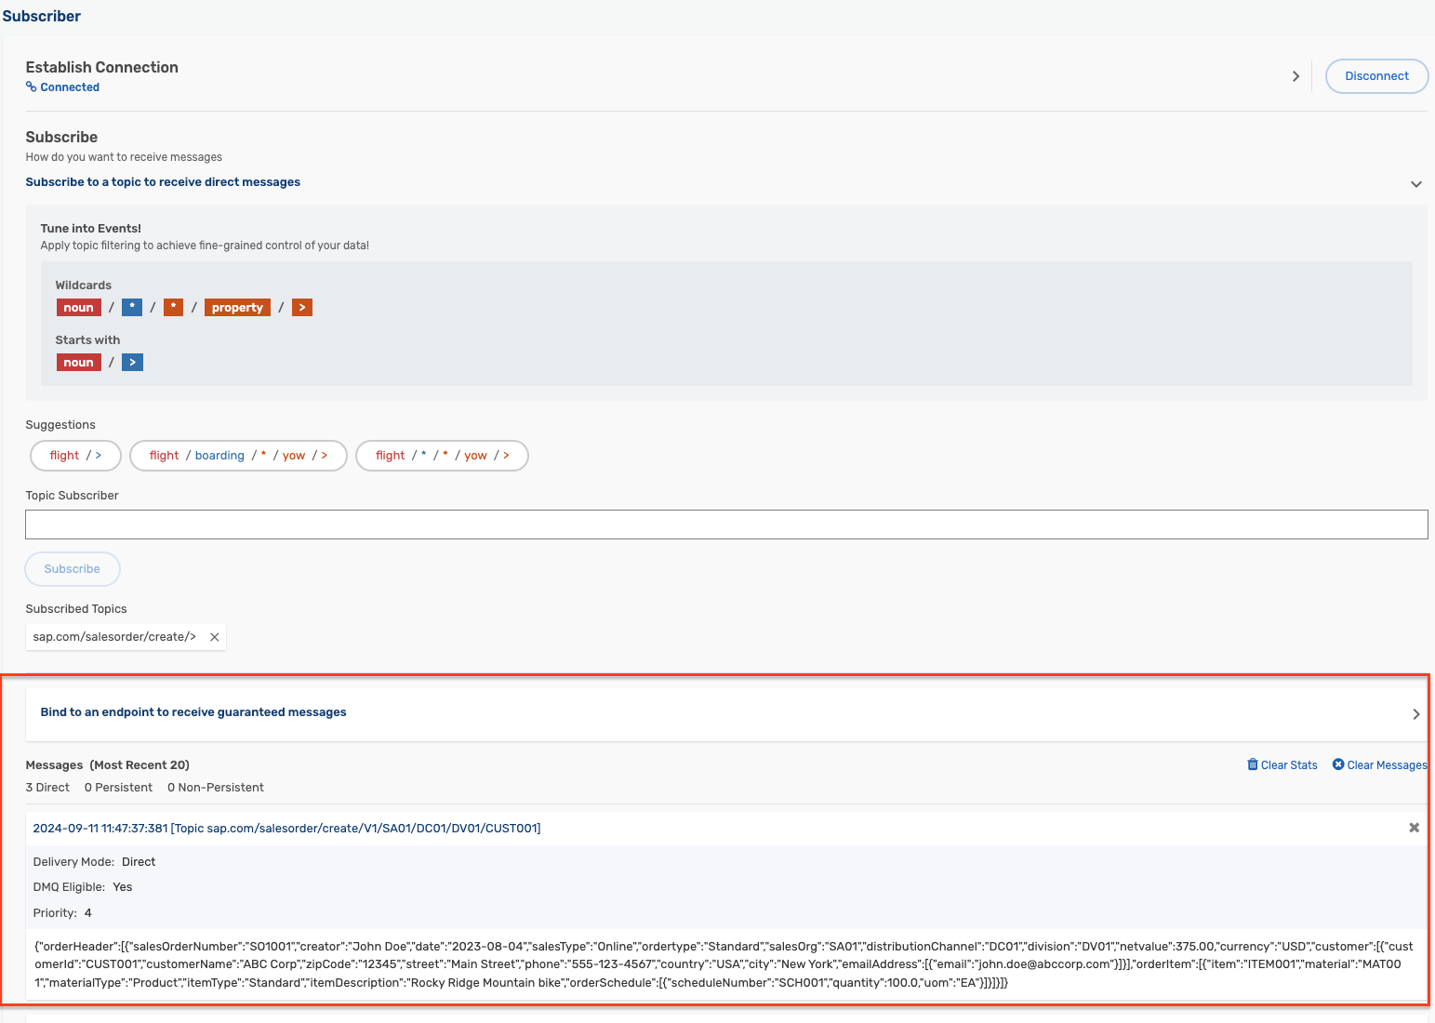

Takeaways

II Deploy SAP Simulator in BTP

II Test Events with AEM Try Me Tab